Coursera Storytelling

<https://www.coursera.org/learn/communicate-with-impact/home/welcome>

### **Week 3: Talk the talk: Creating impressions and guiding influential conversations**

SOLOMON ASCH: Opinions and social pressure

Social pressure is so strong so that sometimes we will lie to ourselves just to conform with the group’s opinion. This is also called Normative social influence. And we don’t even need to know people in the group to be influenced by them. The reason is we want to be accepted in the group by conforming not by what we are saying.

Social Actors (Ervin Goffman’s observation):

As social actors, we have a specific role we have to play and our biggest fear is to do it wrongly and embarrass ourselves or others. To stay together, the team members have to have some level of agreement on how to behave and relate to each other.

Sometimes group decision making becomes dysfunctional.

Janis Irving (Groupthink): sometimes people in the group meeting try to keep the harmony rather than analyzing the situation carefully and maybe have different ideas that might enhance conflicts.

There is a tendency to minimize conflict and reach consensus without sufficiently evaluating and testing ideas. Usually the first decision by the leader gets adopted, especially if the alternative ideas are not clear. Team members censor themselves because they don’t want to be ridiculed and stereotyped. This kind of behavior causes the decisions to be:

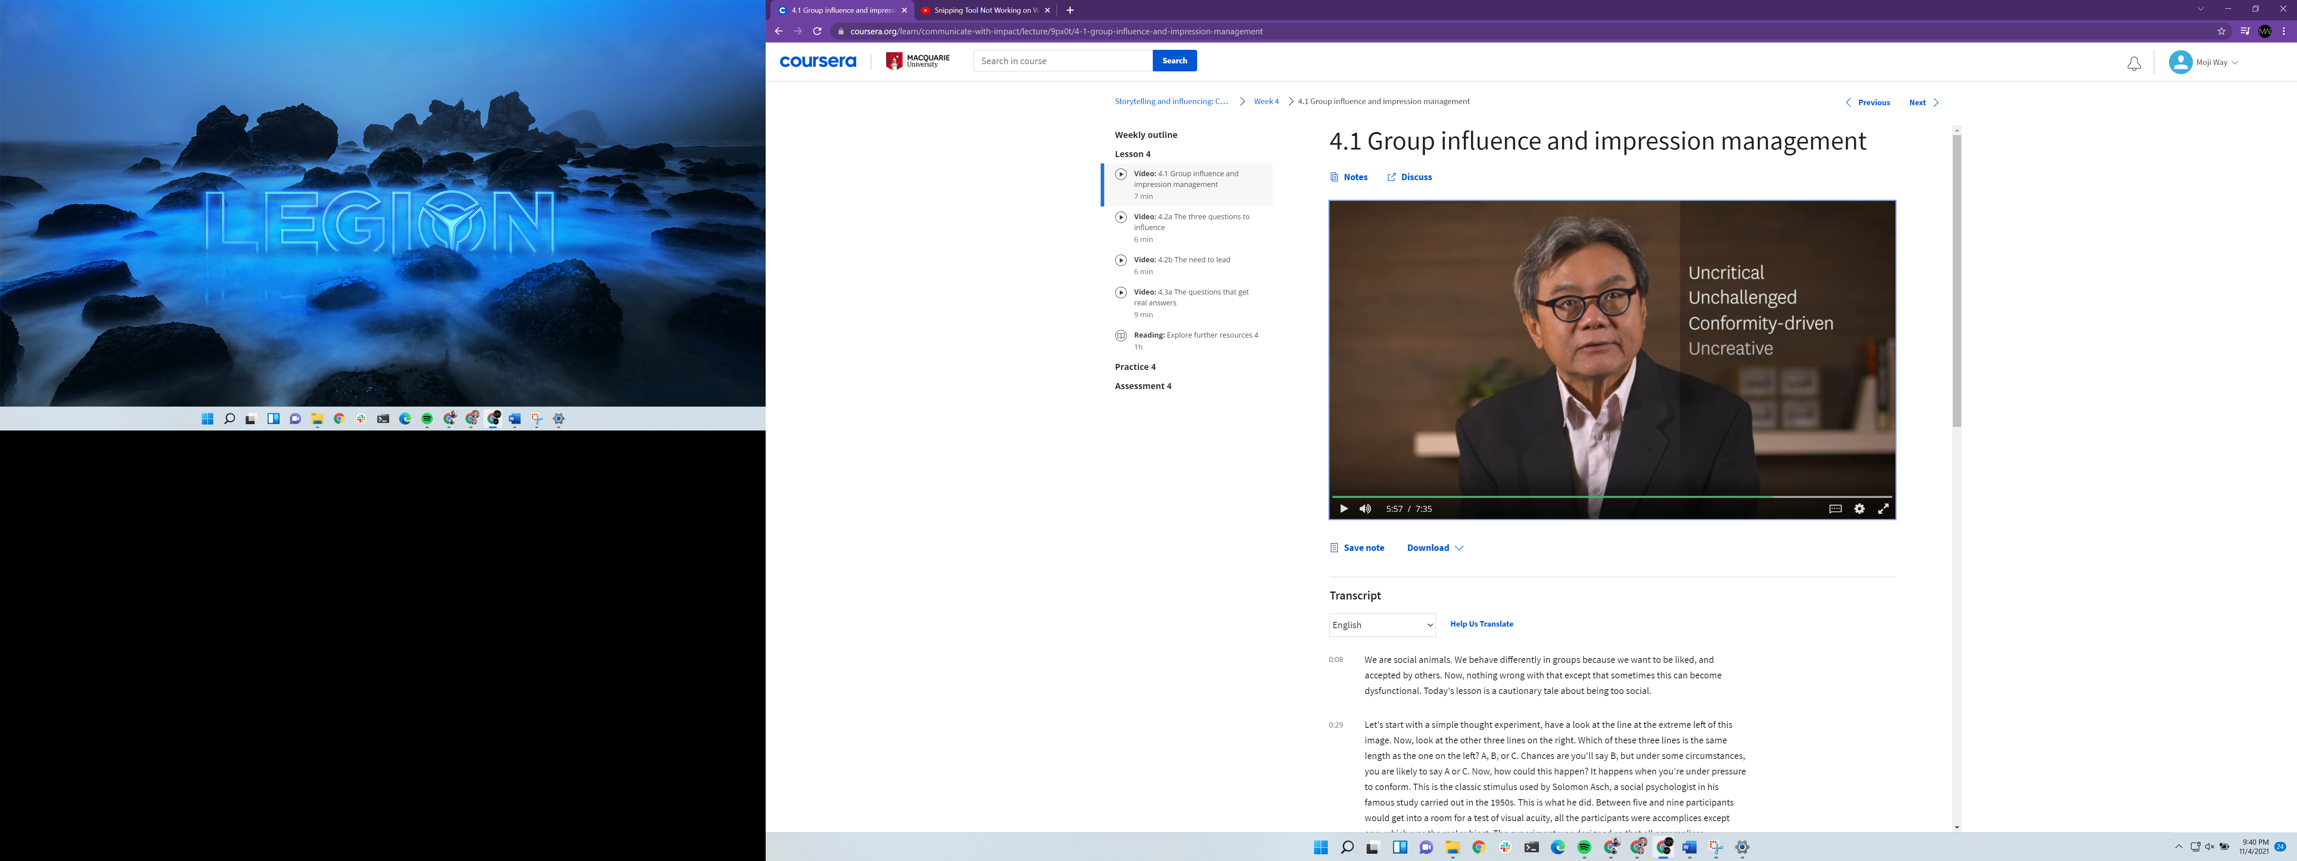

What should a leader do or say to avoid groupthink? There are following tips:

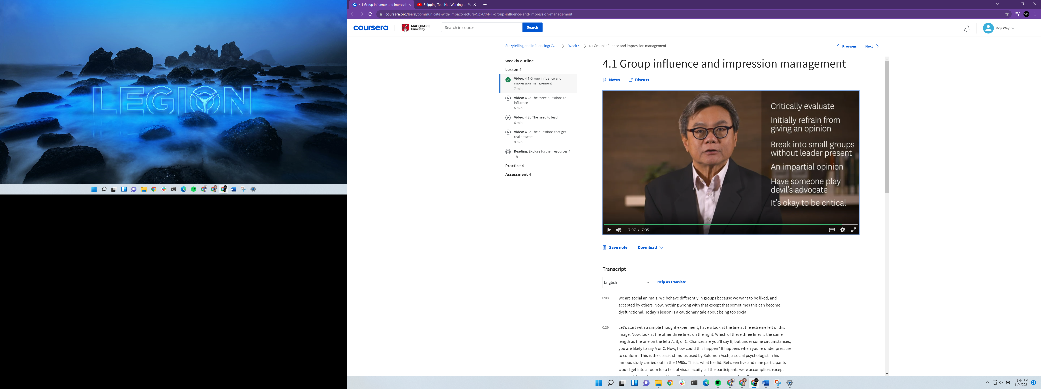

**Tips for meeting planning:**

Before each meeting ask yourself what do you want the people to:

THINK

FEEL

DO

By the end of the meeting. By doing this simple tip you change your meetings effectiveness from 30% to at least 70%.

THINK: Try to use the most concise language to think about what you want people to think. Below the left one is a normal thinking but the right one is what we should try to think they will think.

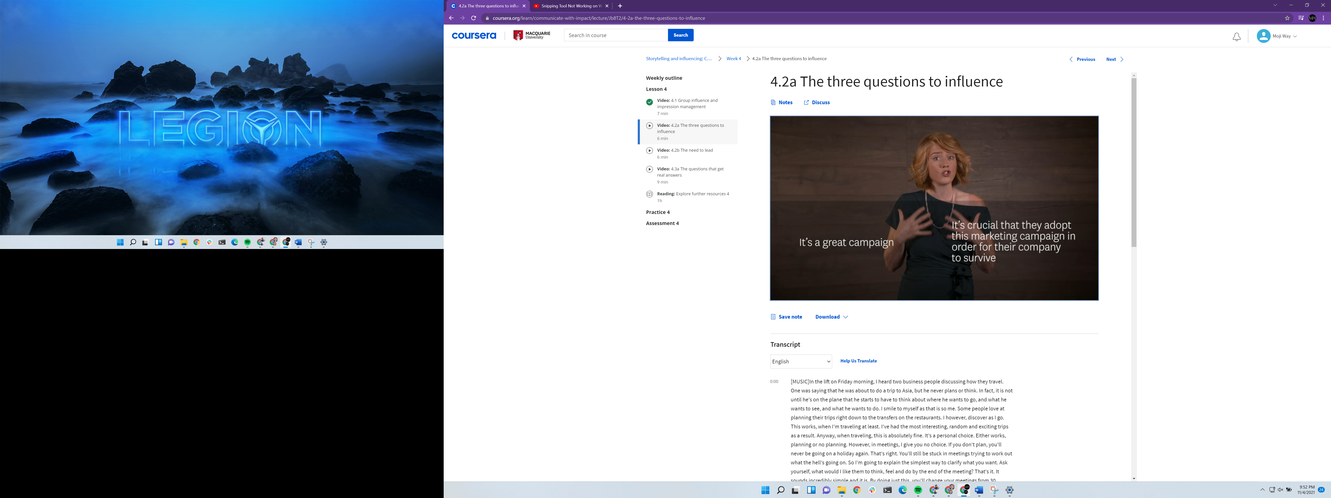

You don’t have to say your expectation to them directly.

FEEL: Use clear compelling language. You want them to be for example reassured, motivated, inspired. This kinds of keywords then automatically change your body language and tone of voice.

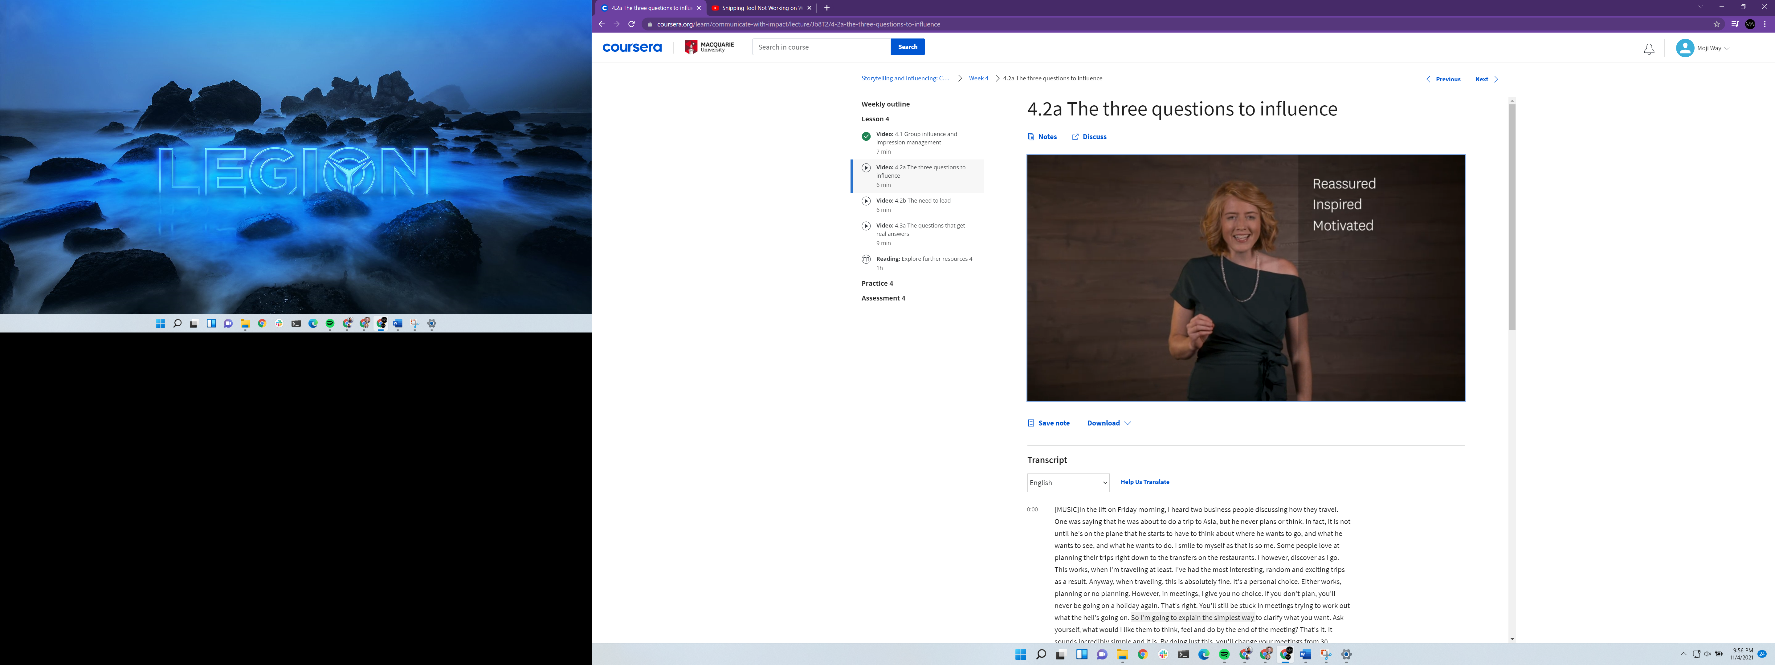

DO: clearly define what you expect them to do at the end of the presentation.

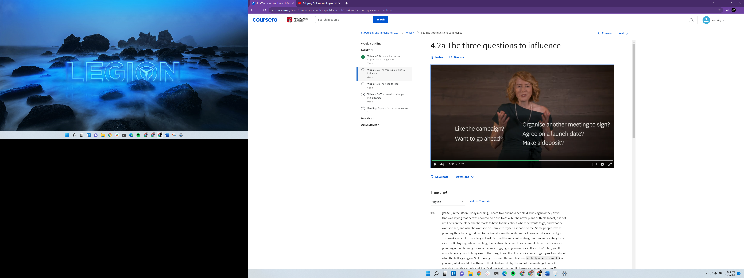

Maybe at the end of the meeting you can have a doc for them to sign. After the meeting send an email to all with all we agreed upon and ask for the receipt for the email.

For all of your conversations, try to be as specific about THINK, FEEL, DO as you can. It’s not good enough to know sort of what you want.

GET SPECIFIC FOR SUCCESS!

Why some meetings go so well?

Because the guidelines at the beginning about how it is going are so clear, so the meeting cannot go wrong.

Some people or managers go off topic and are hard to get them focused. In this situation the relationship gets worse and worse and the team starts to underperform.

**Keeping a meeting on track is the most important part of the meeting.**

Sometimes in meetings the outcomes wont be achieved or they are unknown because:

**The outcomes aren’t agreed on at the beginning.**

If the meeting doesn’t get led properly it will end up in chaos. This is so hard to handle when the person who is organizing the meeting is not leading properly.

**Before we enter the meeting we think about the following:**

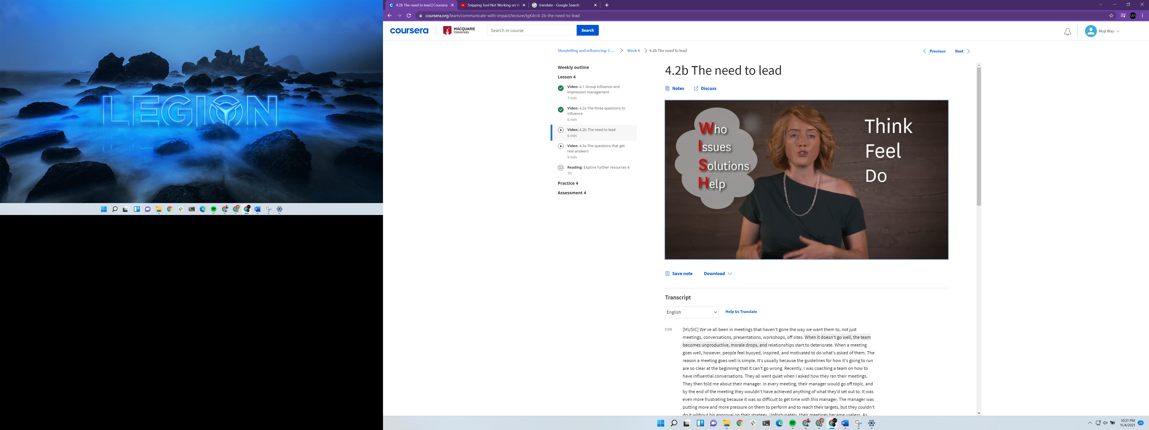

And set your intention, then you can go into the meeting. Then try to build rapport by matching them.

4MAT structure: If you want to lead the meeting you can use this:

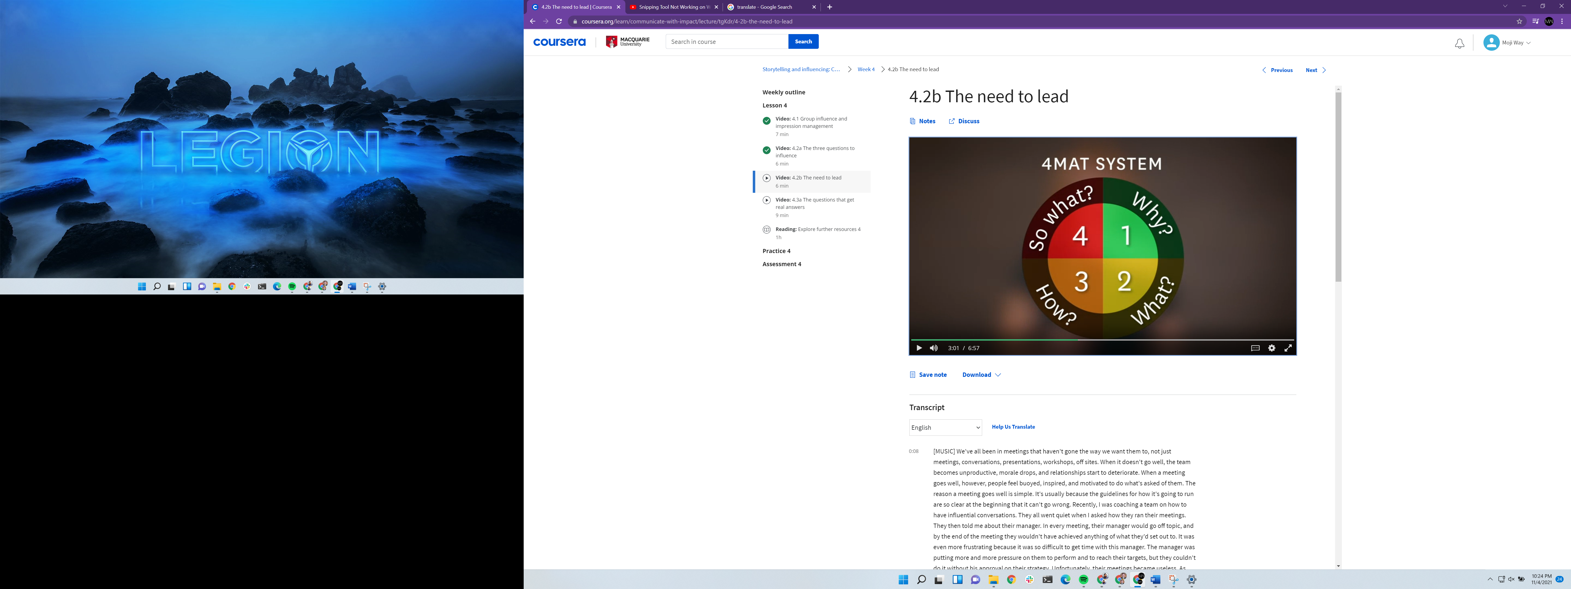

We should be able to answer the above 4 questions upfront. Some people at the audience want an immediate answer to WHY ARE WE HERE? And we should have a very compelling and accurate answer to that, otherwise they switch off immediately.

Make sure to back up your reasoning with data and information to answer WHAT questions. Some other people in the meeting only focus on HOW. They want to know what are you going to do. And at the end there are some people who want to know SO WHAT? What does that mean in this situation. To make sure everybody is onboard, you can ask is there anything that anyone wants to add or change? At the beginning before you start you should get all of their **AGREEMENT & PERMISSION** then you can start.

Usually when ask questions that people are not comfortable to answer we get:

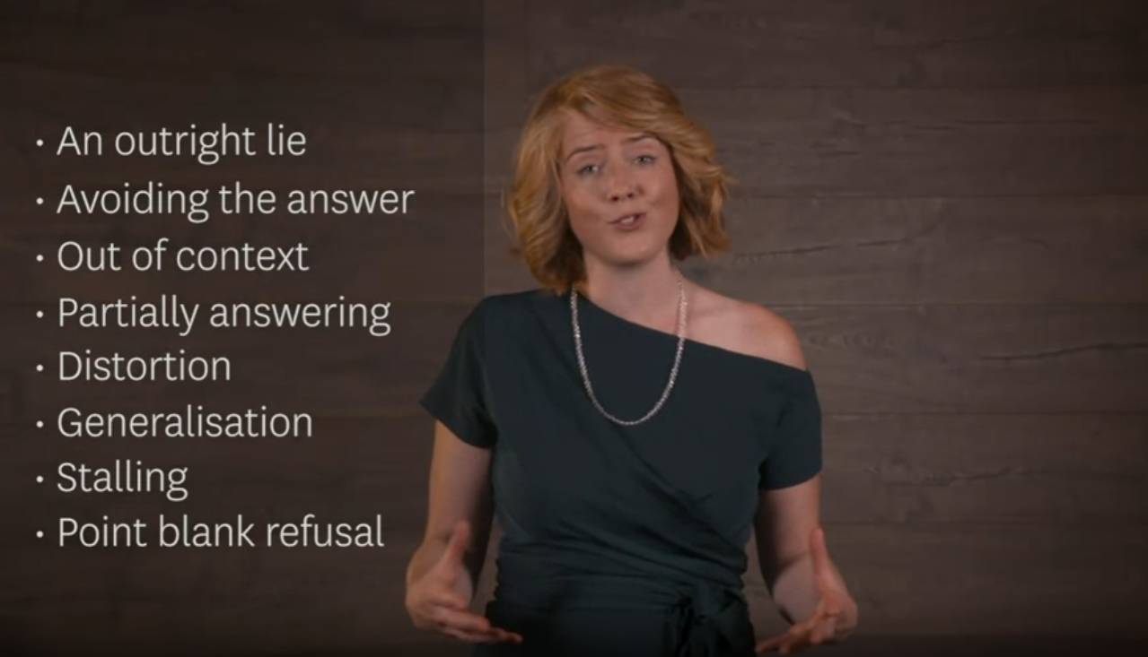

This is because they try to avoid being rejected or looking bad.

How to ask a question to get a real answer?

* Remember if you look around being suspicious to others you will NEVER get the truth.
* And you need to remember what you hear is a part of the truth

Open Questions vs Closed ones:

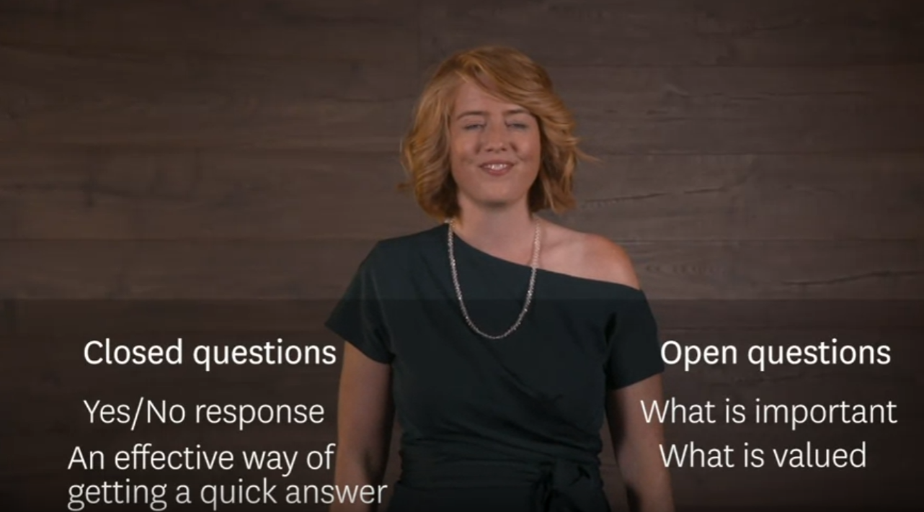

Open questions:

1. **Leaded question:** if you want to influence the response in some ways. The response is already determined. These can be seen as manipulative. Make sure you have enough rapport with the person.

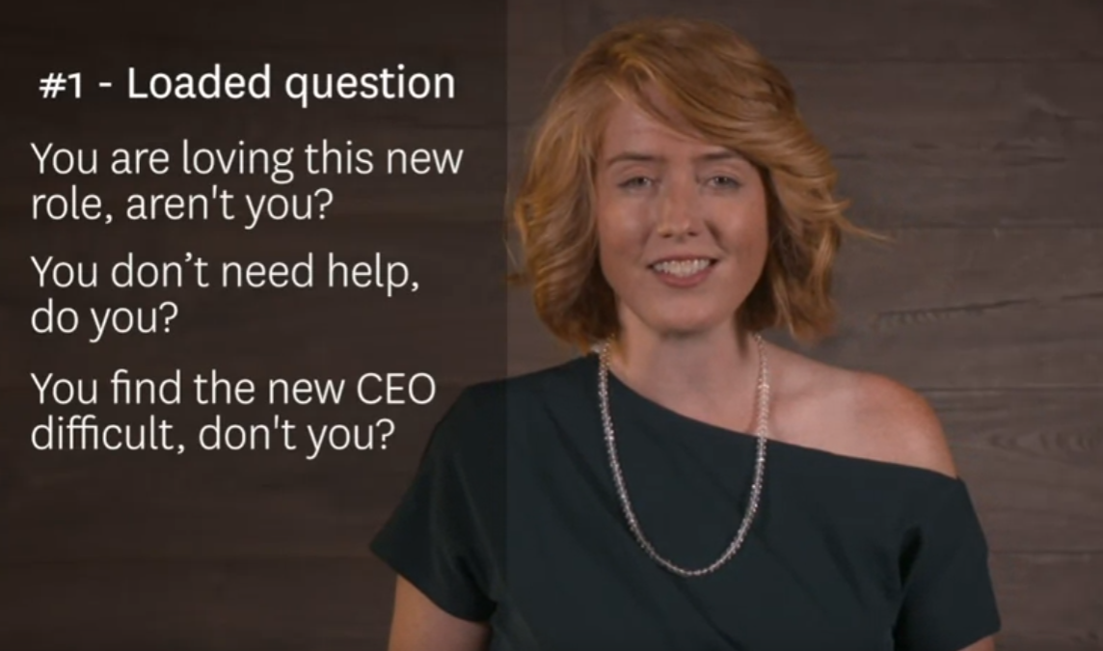

1. **Recall questions:**

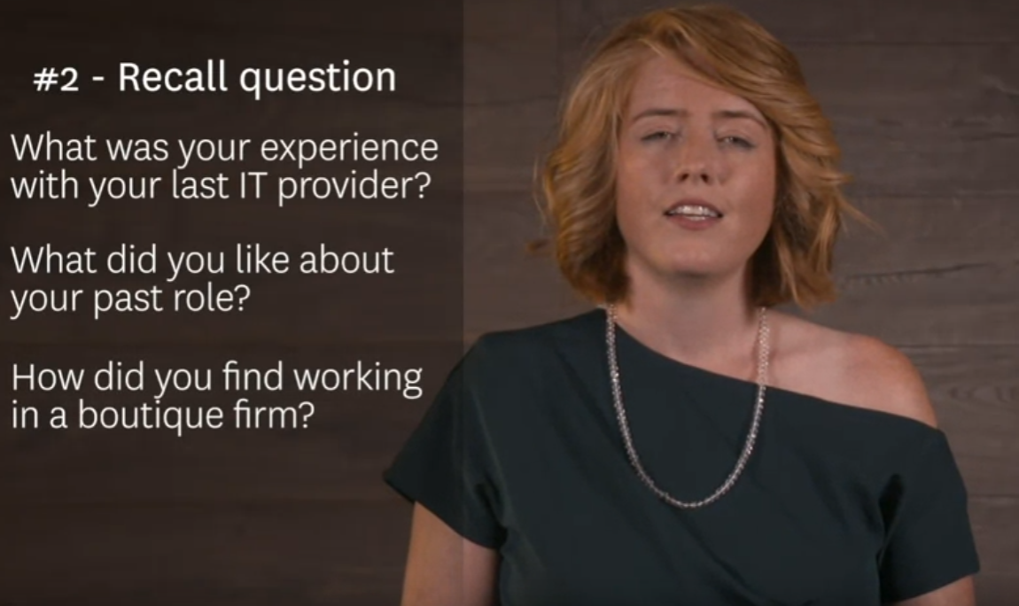

1. **Process questions:** usually refers to HOW questions. You will understand the process of things being done.

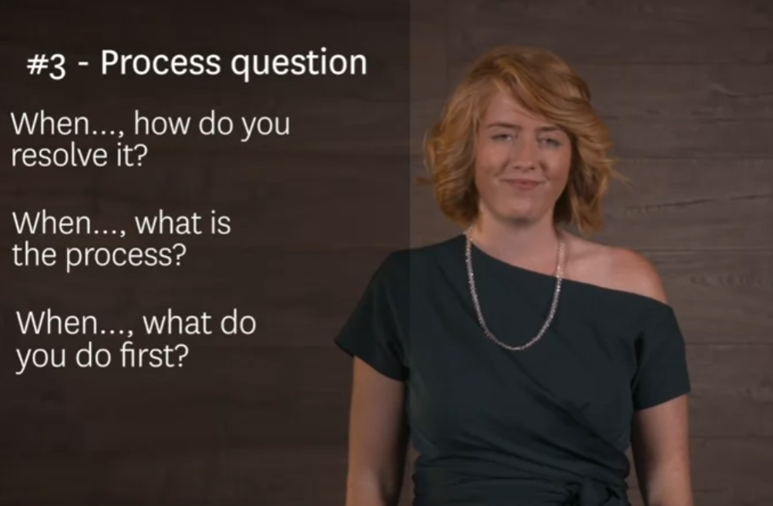

1. **Funneling questions:** To find more and more detailed information

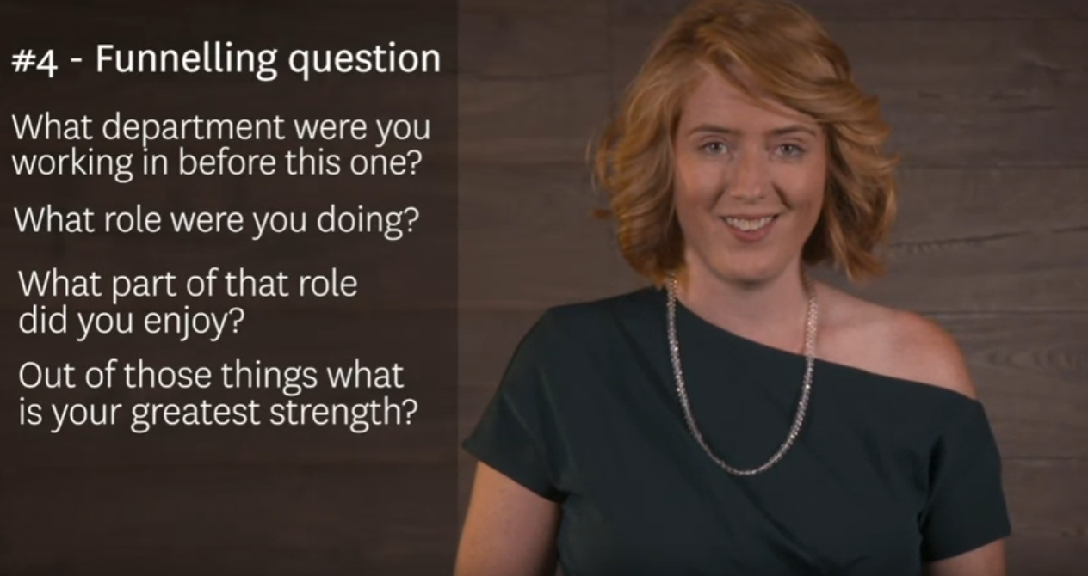

1. Repetition question: when you ask the same question over and over. (5 why)

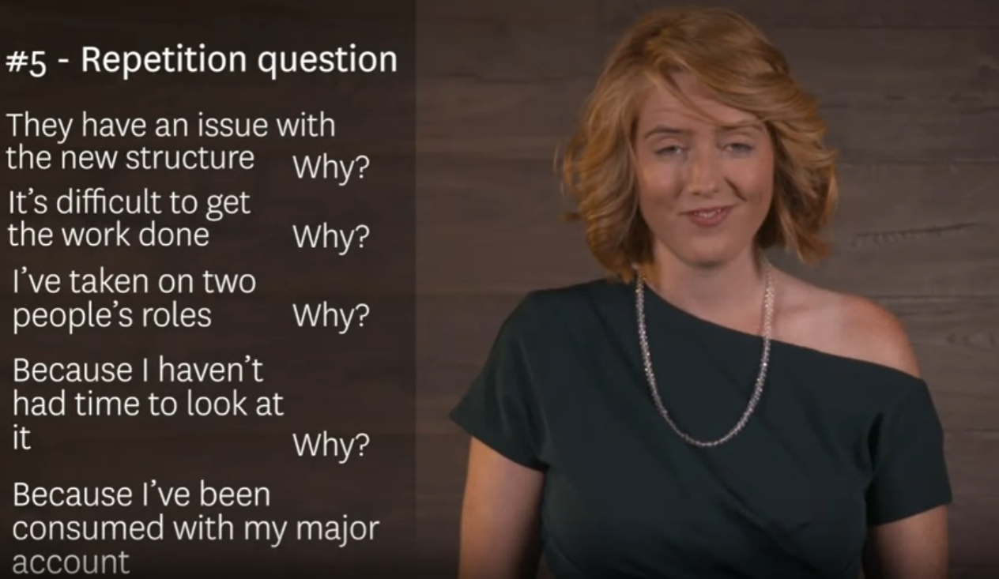

Top 4 advanced questions to use as repeating questions:

* **Why is that a problem?** Sometimes we assume we know what the problem is without asking for enough details. If you assume you may come up with a solution that is not useful.
* **For what purpose?** Sometimes if we are so stuck with one solution, we wont be able to see other ways of achieving a task but this question can help seeing the bigger picture.

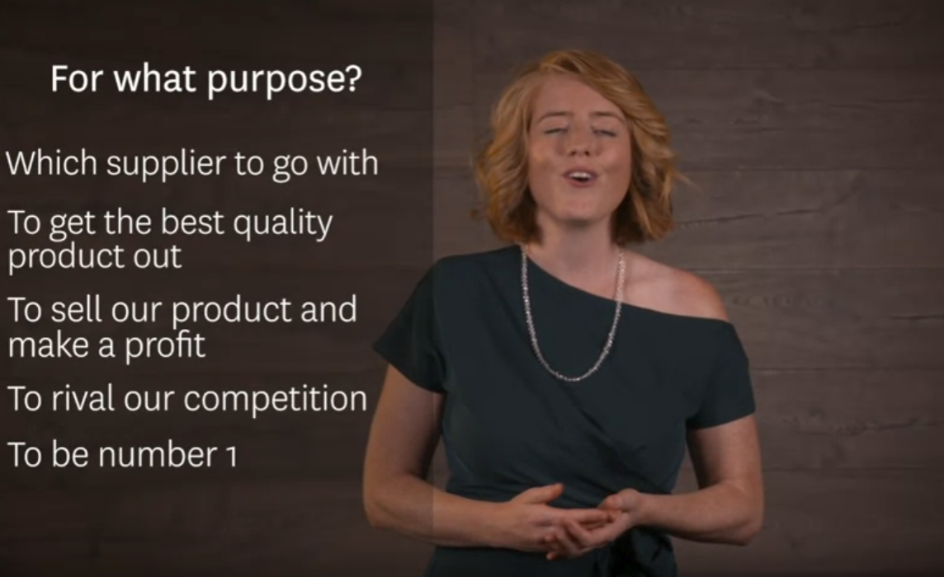

* What specifically? If you have the big picture, you want to go into more details and this is when you ask this question.

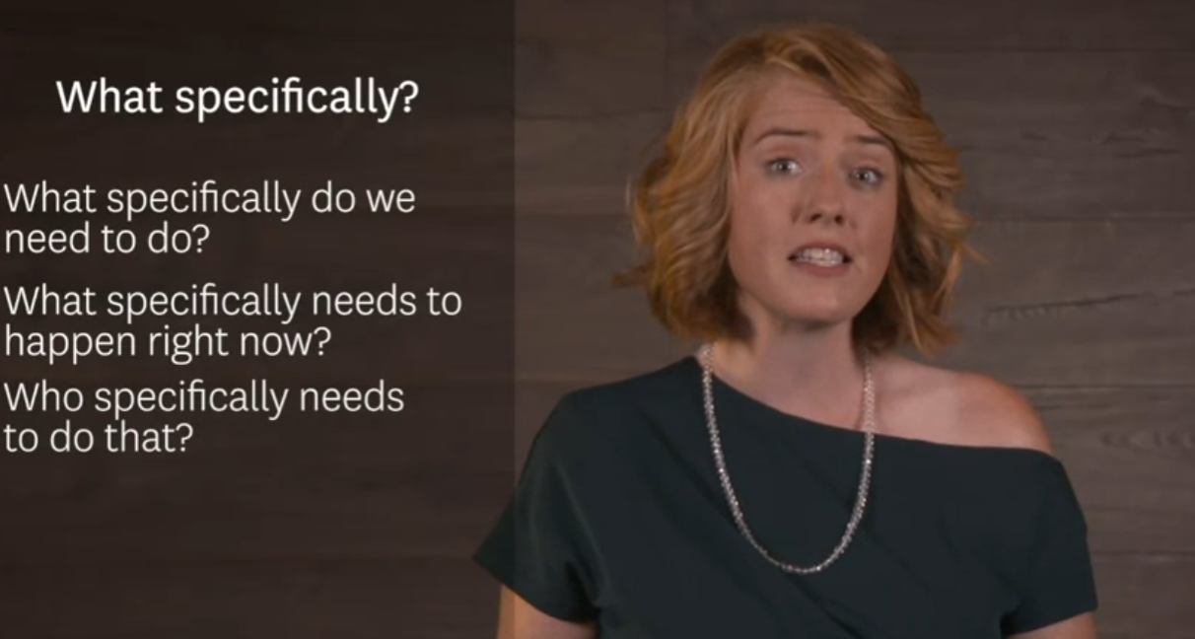

You can always follow:

